Data analysis of livable conditions in selected cities in India based on Sustainable Development Goals

Sanjna Sukirti R
2023PECCS368
211423104583
B.E Computer Science and Engineering
Panimalar Engineering College
Chennai, India

Abstract: Rapid urbanization in India has created severe challenges for sustainable living, with cities experiencing increasing air and water pollution, overcrowding, health disparities, and poverty. This research develops a data-driven livability index for selected Indian cities, based on the United Nations Sustainable Development Goals (SDGs), to provide a holistic evaluation of urban conditions. The study integrates multiple dimensions - air quality, health outcomes, population density, and poverty levels - into a composite scoring framework using normalization and weighted aggregation. By combining datasets from official government portals, international sources, and open data platforms, the model ensures both reliability and scalability. Unlike existing studies that focus on isolated aspects such as environmental quality or infrastructure, this work uniquely constructs a composite, SDG-aligned index to capture interdependencies across urban systems. The findings highlight variations in livability across cities, identify areas requiring urgent policy intervention, and demonstrate the potential of data analytics in supporting planners, researchers, and municipal authorities. The approach not only offers a replicable methodology for other Indian cities but also contributes toward monitoring India’s progress on SDG 1 (No Poverty), SDG 3 (Good Health and Well-being), and SDG 11 (Sustainable Cities and Communities). By bridging gaps in prior research and offering a scalable analytical framework, this study lays the groundwork for informed, evidence-based urban planning and sustainable development practices.
Keywords—Livability Index, Urban Analytics, Data Analysis, Livable Conditions, Livability, Sustainable Development Goals, Urban Livability Conditions

Introduction
India’s rapid urbanization has led to growing concerns about the quality of life in its cities. Rising air and water pollution, overcrowding, poverty, and uneven access to healthcare are placing immense pressure on urban systems. The United Nations Human Development Report says that India’s Human Development Index (HDI) remains in the medium range, reflecting persistent developmental challenges despite overall economic progress. Assessing and improving urban livability has therefore become a critical priority for policymakers and researchers, especially with respect to the Sustainable Development Goals (SDGs).
While existing studies have attempted to measure livability through environmental, infrastructure, or governance indicators, these efforts are often fragmented and lack integration with SDGs as a guiding framework. Most indices either focus narrowly on one domain, such as environmental quality, or rely on general perception-based measures that fail to capture multi-dimensional realities. This creates a gap in establishing a comprehensive, data-driven, and policy-relevant approach to evaluate livable conditions in Indian cities.
This study addresses that gap by proposing a composite livability index for selected Indian cities, incorporating indicators of air quality (PM2.5, PM10, NO₂, SO₂), population density, poverty levels, and health outcomes. The research hypothesizes that combining these dimensions into a unified index will highlight disparities in livability across cities while directly linking results to SDG 1 (No Poverty), SDG 3 (Good Health and Well-being), and SDG 11 (Sustainable Cities and Communities).
The motivation for this work is to contribute a transparent, replicable methodology that bridges environmental, social, and health dimensions. By doing so, the study not only offers a tool for diagnosing urban challenges but also supports evidence-based policymaking and advances India’s progress toward sustainable urban development.

METHODOLOGY
The central research question guiding this study is: How can livable conditions in selected Indian cities be systematically measured using a multi-dimensional, SDG-aligned data-driven framework? To address this, a composite Livability Index (LI) was developed, integrating environmental, health, demographic, and socio-economic indicators into a unified scoring system. The framework aligns with UN Sustainable Development Goals (SDGs), particularly SDG 1 (No Poverty), SDG 3 (Good Health and Well-being), and SDG 11 (Sustainable Cities and Communities).

Study Area and Period
Five major Indian cities - Delhi, Mumbai, Bengaluru, Chennai, and Kolkata - were selected as case studies due to their population size, economic importance, and availability of monitoring data. The analysis was conducted for the period 2019–2023, depending on data availability for individual indicators.

Indicators
Indicators were chosen based on relevance to SDG targets and availability of reliable data:
- Air quality: PM₂.₅, PM₁₀, NO₂, SO₂
- Health: Infant Mortality Rate (IMR), Life Expectancy (LE)
- Demographics: Population, Area, Population Density (PD)
- Socio-economic: Below Poverty Line (BPL) households

Data Collection
Air quality indicators (PM₂.₅, PM₁₀, NO₂, SO₂) were obtained from the Kaggle datasets “Indian Cities AQI (2020 - 2024)” and “Time Series Air Quality Data of India (2010-2023)” which are based on Central Pollution Control Board (CPCB) Air Quality data. Health indicators like life expectancy and infant mortality rate (IMR) were sourced from the Sample Registration System (SRS) and National Family Health Survey (NFHS-5, 2020–21). Socio-economic data on below-poverty-line (BPL) households were obtained from the Open Government Data (OGD) platform and state-level poverty reports. Demographic data (population and area) were collected from the Census of India 2011, with updated estimates from respective city and metropolitan area municipal corporations.

Data Processing
All indicators were compiled into structured city-year datasets. For the indicators where city-level data was not available, state or metropolitan area proxies were given with references. Annual averages were calculated where continuous monitoring data were available. Population density was computed as:
$PD=\frac{Population}{Area}$ (1)

Normalization
To allow comparability across heterogeneous indicators, min–max normalization was applied to rescale each indicator between 0 and 1:
${Score}_{i}=\frac{X-X_{min}}{X_{max}-X_{min}}$ (2)
for indicators where higher values indicate better conditions (e.g., Life expectancy), and
${Score}_{i}=\frac{X_{max}-X}{X_{max}-X_{min}}$ (3)
for indicators where higher values indicate worse conditions (e.g., PM₁₀, PM₂.₅, IMR, etc).

Sub-Index Construction
- Air Quality Index (AQI)
Air quality was aggregated from normalized pollutant indicators:
$AQI=\frac{{PM2.5}^{norm}+{PM10}^{norm}+{NO2}^{norm}+{SO2}^{norm}}{4}$ (4)
- Health Index (HI)
Health was measured using Life Expectancy and Infant Mortality Rate:
${LE}^{norm}=\frac{LE-{LE}_{min}}{{LE}_{max}-{LE}_{min}}$ (5)
${IMR}^{norm}=\frac{{IMR}_{max}-IMR}{{IMR}_{max}-{IMR}_{min}}$ (6)
$HI=\frac{{LE}^{norm}+{IMR}^{norm}}{2}$ (7)
- Population Density Index (PDI)
Population density was normalized as a negative indicator:
$PDI=\frac{{PD}_{max }-PD}{{PD}_{max}-{PD}_{min}}$ (8)
- Poverty Index (BPL Index)
The below-poverty-line population was normalized similarly:
$BPL_Index=\frac{{BPL}_{max}-BPL}{{BPL}_{max}-{BPL}_{min}}$ (9)

Composite Livability Index (LI)
The composite Livability Index (LI) for each city and year was calculated by taking weighted average across indicators using the formula:
$LI=w_{1}∙AQI+ w_{2}∙HI+ w_{3}∙PDI+ w_{4}∙BPL_Index$ (10)
In this study, equal weights (w_{i} = 0.25) were applied to all sub-indices, following UN SDG values and literature.
The final index was scaled to a 0–100 range for interpretability:
$${LI}_{\%}=LI ×100$$

LITERATURE REVIEW
- Salve et al (2020) have analysed the living comfort of people in different cities in India using Geographic Information System by proposing a prototype to examine livability in cities. They have proposed a system that can provide an overview of the lifestyle in a specific area through locality indexing based on ease of living categorised based on age groups, covering various indicators. They used data from Google Maps Places API and data.gov.in (Indian government website). They showed three indexing techniques, Dimensional Index Methodology, Z-Score or Standardization and Decile Scale Ranking. They mined data and required information was summarised generating the end result in the form of visualisation charts.
- Shruti et al (2021) have evaluated the environmental sustainability of smart cities in India based on the design and application of the Indian Smart City Environmental Sustainability Index. They have developed Smart City Environmental Sustainability Index (SCESI) using 24 environmental indicators, to classify cities on 5 categories using 0 – 100 increasing scale, based on decreasing SCESI. They found through SCESI that Delhi, Allahabad and Bhubaneswar are in a fair range while Varanasi and Patna performed poorly, in environmental sustainability. They concluded that SCESI effectively show the environmental sustainability gaps and can help in planning and managing services connected with environmental sustainability.
- Saeed et al (2022) have developed an integrated approach for creating an Urban Livability Composite Index, aiming to be a road map for ranking cities based on their livability. They have studied 8 major cities in Punjab, Pakistan where they combined spatial and non-spatial indicators, applied geometric means and Analytical Hierarchy Process (AHP) to compute a weighted Composite Livability Index. They found that the index depict significant disparities among the cities where Lahore is ranked highest overall but showed weakness in connectivity and traffic congestion and public infrastructure while Rawalpindi being second-best, excelled in individual well-being, urban economy and environment. They concluded that the Composite Livability Index would help to rank and diagnose urban livability and suggested policy suggestions for decision makers in improving the cities.
- Jayanandini et al (2023) have evaluated the urban liveability index with data-centric results from smart cities in India. They have proposed the Urban Liveability Index Analysis with Indian Cities (ULIA-IC) approach using a sample from 15 Indian cities and found that it greatly improves accuracy and reliability when it is applied to urban measures, with deviation of 2.54 in air quality, 193.9 in population density, 0.56 for green space coverage, 79.47 for traffic congestion. They concluded that the proposed ULIA-IC offers practical viewpoints to assist urban planners and policymakers in improving overall quality of urban life.
- Safiullah and Kumar (2023) have studied the measurement approach of “Ease of Living” concept of the Smart City Mission with sample case of Lucknow city, Uttar Pradesh, to find gaps between the index scores and realities mainly in perspective of strength and weakness in governance aspect. They observed the effect of the indicator ratings on the ongoing projects and found few gaps in measuring the situations as there was very little clearness on the ‘on ground’ situation from the index, lacking perspective on strengths and weaknesses of the city. They concluded that the Ease of Living index provides a structured data driven metric for urban development but often presents an incomplete or misleading picture due to inconsistent collection methods, overshadowing the actual reality of the city’s development and experience, thus requiring improved data governance and citizen-inclusive implementation strategies.
- Gareiou et al (2023) have reviewed the composite environmental indicators. They reviewed and reported the main composite environmental indicators which are Sustainable Development Goals Index, Ecological Footprint, Environmental Performance Index, Environmental Sustainable Index, AQI, Policy Performance Index, etc. They found that the indicators cover the relations between the environment, the economic and social sectors or a combination of specific environmental indicators. They concluded that the composite environmental indicators are important tools for the checking the quality and status of progress and performance based on the environment.
- Subramanian (2024) has compared the Ease of Living parameters and Urban Greening Index for the most liveable Indian cities based on the 2018 EOLI report, focussing on Mumbai. The author used Landsat 8 remote sensing imagery with different summer and winter types for 2016 and 2019 and conducted geospatial analysis using GIS to derive UGI for the city. The author found that the methods of EOLI to derive green indicators are insufficient to assess the ground realities, lacking actual consideration of important aspects like vegetation quality, accessibility, etc. The author concluded that there is a need for adding qualitative and perception-based indicators and provided with revised indicators that can be used for better assessment of EOL for Indian cities.
- Ran et al (2024) have conducted coordination analysis with urban livability and population spread in China’s major urban agglomerations. They used data from 2010, 2015 and 2020 and established a comprehensive index called Coordination Distance Index (CDI), covering aspects of social–economic development and ecosystem facilities. They found that most cities had improvements in their coordination levels from 2010 to 2020, notably from Yangtze River Delta (YRD), Pearl River Delta (PRD), which showed “high coordination” by 2020 and that those with low coordination require spatial planning adjustments. They concluded that the proposed method will help to refine urbanisation development and population regulation.
- Satiawan et al (2024) have calculated the liveability index for Tuban Regency, East Java, for achieving liveability in the city. They have conducted measurement from before and after the pandemic (2020 to 2023) and used district data units to measure the liveability index achievement. They found that in rural areas the index is higher than the urban area in terms of environmental factors, food security, housing and settlements, and accessibility and transportation. They concluded that though rural areas show better liveability index, there is a possibility that urban areas can have a better liveability index than rural related to the fulfilment of basic human needs to live comfortably and the condition of an area.
- Yan et al (2025) have created an indicator system for livable cities on the basis of Sustainable Development Goals (SDGs) using empirical research in China. They established an evaluation system that can be scientific and universally applicable for urban livability, to show that building livable cities help to promote sustainable development, using the “Indicator Library for Cities’ Sustainable Development (ILCSD)”. They selected 24 sample cities to analyze the different levels in the proposed system and derived a set of indicators for evaluating livability of cities with focus on the SDGs. They concluded that the proposed index system would help to enhance urban livability and promote the implementation of Sustainable Development Goals.
- Haksevenler et al (2025) have integrated sustainable development and urban management by creating a Green City Index for cities for assessing and comparing the sustainability of the urban districts, by studying Istanbul, Türkiye. They established the Green City Index using the Analytic Hierarchy Process and found that no district’s environmental performance is sufficiently strong as the highest scoring district achieved only 59/100, showing lack of environment quality (EQ). They concluded that the Green City Index can help decision makers to assess and improve sustainability efforts in line with long term goals for strategic urban management.
- Rajesha and Chandrashekara (2025) have discussed the frameworks and approaches for sustainable cities in the light of their exploration on urban liveability. They used secondary data and found that despites challenges in measurement and assessment, there needs to be integrated approaches and cross-sector collaboration to address urbanisation problems properly. They also found that with the incorporation of factors like social inclusion, environmental sustainability, economic prosperity, and cultural amenities, urban planners can create more resilient, vibrant, and equitable cities, linking the liveability concept to global sustainability goals, as evidenced by international pacts like the Sustainable Development Goals and the New Urban Agenda. They concluded by highlighting the significance of considering diverse factors and perspectives in shaping urban liveability.
- Thorat et al (2023) have analysed the Liveability Index parameters for formulating assessment model at the Zone level, through the case of Pune City, India. They proposed to identify and investigate a few key elements in determining liveability and developing a liveability rating system. They found that peripheral region requires improvement in safety measures, unplanned areas performed well in health and education than other regions, and planned areas achieved satisfactory in social cultural element, transportation and mobility. They further created the framework based on the three zones, providing with proposals aiming to address the specific needs and gaps in each of these areas. They concluded that stakeholders will be able to prioritise and implement policies that would increase the standards of living hence improving the city’s overall liveability.
- Kashi et al (2025) have done spatial analysis and ranked urban cities based on a comprehensive livability approach, through the case of Tehran. They have proposed a framework for assessing and spatially analysing urban livability in Tehran’s districts which includes applying Analytical Hierarchy Process-Alternatives with Weights of Criterion method and used Exploratory Factor Analysis, Standard Deviational Ellipse, Hot Spot Analysis, and Network Analysis. They found that northern districts show more favourable conditions while central and southern districts have lower levels of livability. They concluded that spatial justice in service access is important and that advocated for citizen participation in urban planning and development.

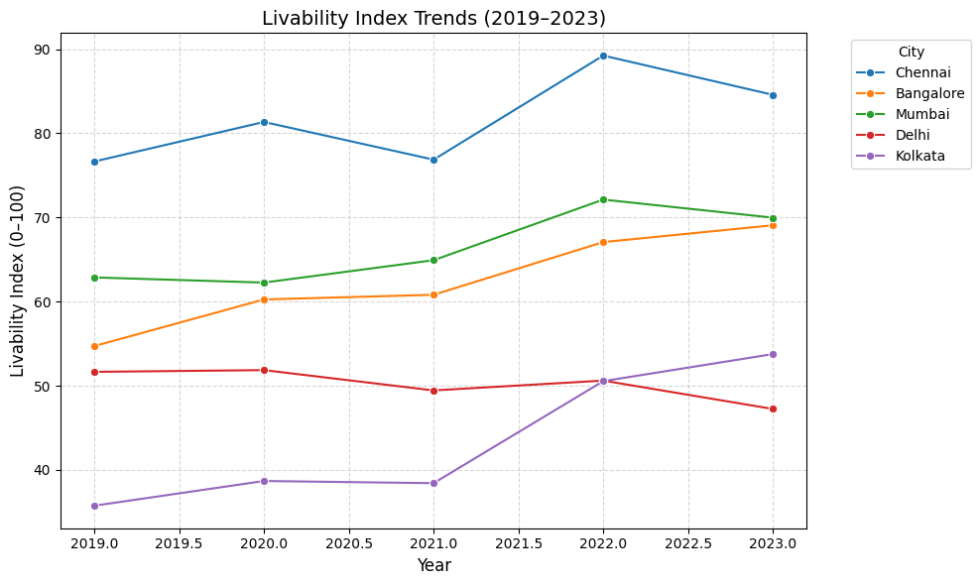
RESULTS

The line plot presents the temporal variation of the livability index for all five cities between 2019 and 2023. The line plot shows Chennai consistently holding the highest livability scores, while Delhi and Kolkata remain at the lower end across all years.
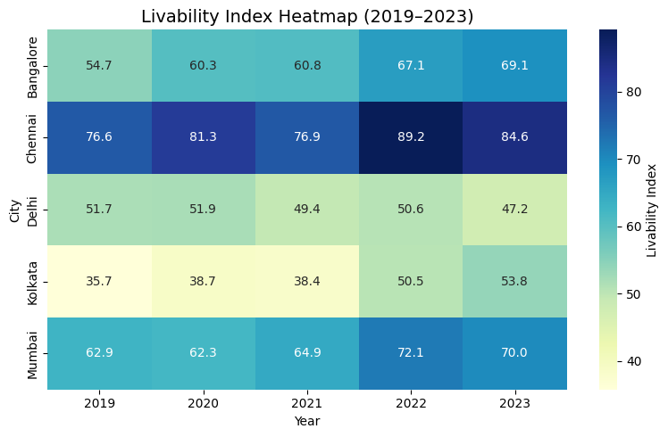

The heatmap displays the comparative livability index values of cities across the five-year period. The heatmap displays clear differences, with Delhi and Kolkata in darker shades, while Chennai stays in lighter tones across the years.

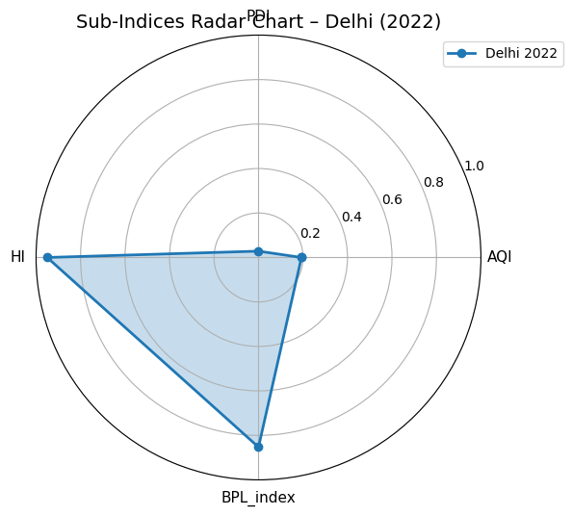

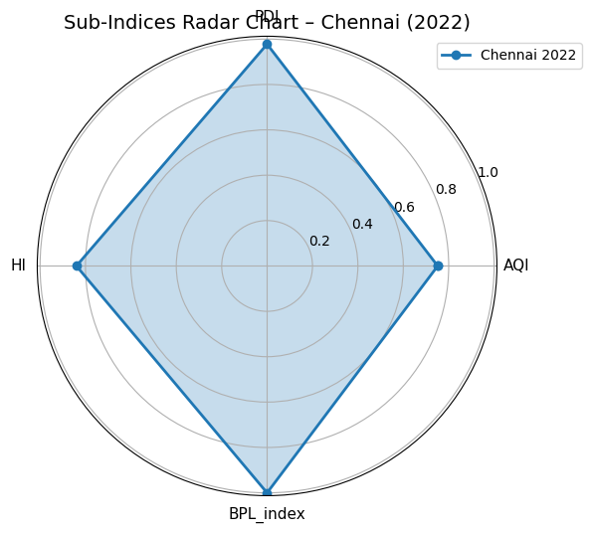

The radar chart illustrates the relative performance of Delhi and Chennai across four dimensions: air quality (AQI), population density (PDI), health index (HI), and poverty index (BPL).
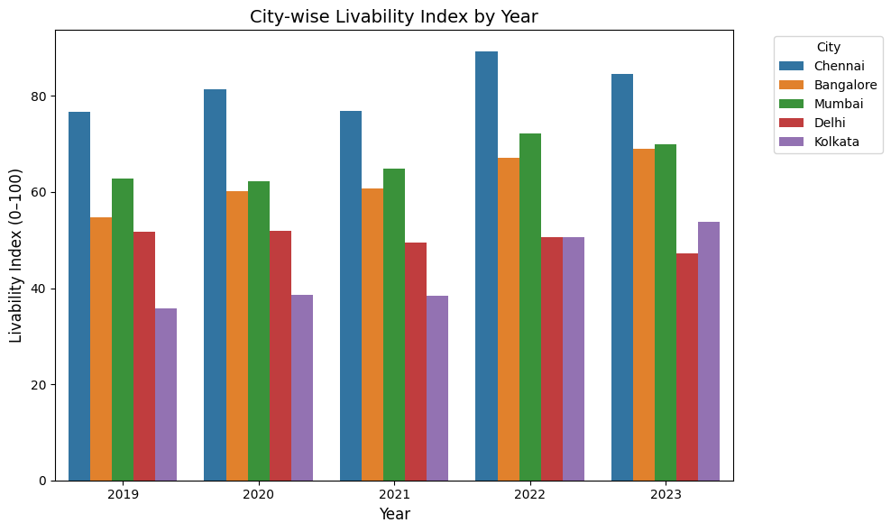
The grouped bar chart illustrates inter-city comparison of livability index scores within each year. The grouped bar chart demonstrates that Chennai consistently outperforms other cities in every year of the analysis, whereas Delhi ranks lowest throughout the period.
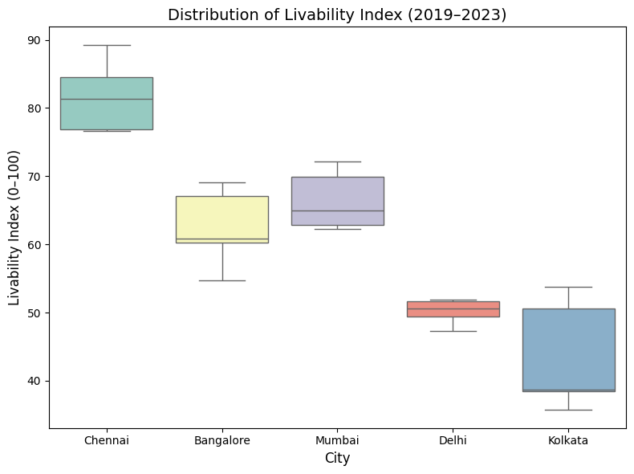

The boxplot summarizes the distribution of livability index scores for each city over the study period. The distribution analysis shows that Chennai exhibits a narrow and high-range spread of scores, whereas Kolkata demonstrates a wider distribution with notable upward shifts.
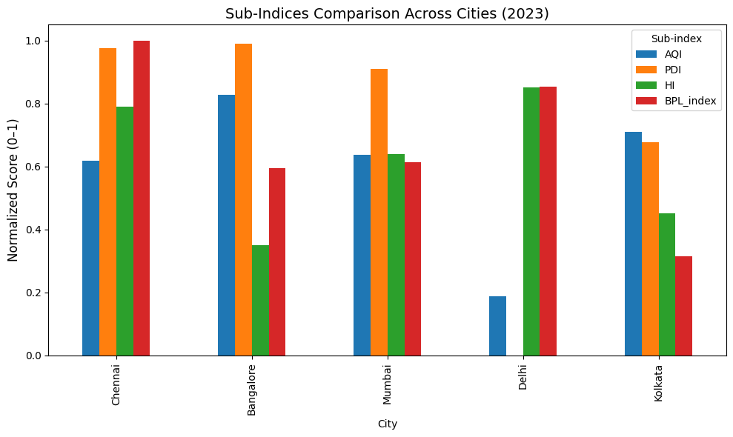
The grouped bar chart compares the normalized scores of four sub-indices - Air Quality Index (AQI), Population Density Index (PDI), Health Index (HI), and Below Poverty Line Index (BPL_index) - across the five cities for the year 2023. The sub-index comparison highlights Delhi’s weakness in AQI and PDI, whereas Chennai shows balanced performance across all dimensions.

DISCUSSION
Figure 1: Chennai consistently achieves the highest scores, reflecting balanced performance across indicators. Bangalore shows moderate but steady improvement over the years. Mumbai remains stable with mid-range scores, suggesting incremental but limited progress. Delhi records the lowest values throughout due to poor air quality and density pressures, while Kolkata demonstrates gradual improvement, indicating gains in poverty reduction and health outcomes.

Figure 2: The color gradation highlights Chennai as the most livable city in the dataset. Bangalore and Mumbai occupy the middle range, with Mumbai slightly outperforming Bangalore in later years. Delhi remains consistently low, while Kolkata shows clear improvement, especially after 2021, signaling gradual policy effectiveness.

Figure 3: Chennai performs evenly across all four sub-indices, while Mumbai and Bangalore show moderate but uneven strengths. Delhi’s weaknesses in air quality and density dominate its profile, despite reasonable health outcomes. Kolkata demonstrates improvement in poverty and health, though environmental indicators still limit its overall livability.

Figure 4: Chennai leads in every year, followed by Mumbai and Bangalore, which are closely aligned. Kolkata begins at a low level but rises over time, narrowing the gap with mid-performing cities. Delhi remains lowest across the years, underlining persistent structural challenges.

Figure 5: Chennai’s compact and higher distribution indicates stability and resilience. Bangalore and Mumbai display mid-level consistency, reflecting moderate but stable urban conditions. Kolkata’s wider distribution suggests variability but also upward movement in livability. Delhi’s low and narrow spread demonstrates entrenched urban stress with minimal fluctuation.

Figure 6: Chennai shows strong and balanced scores across all sub-indices, reflecting well-rounded urban management. Bangalore performs well on population density but has noticeable gaps in health and poverty. Mumbai maintains moderate scores across all sub-indices but does not excel in any. Delhi stands out with very low air quality and population density scores but performs better in health and poverty indices. Kolkata achieves decent results for health and air quality yet falls short on poverty reduction, indicating uneven progress among its sub-indices. The visualization highlights where each city faces its greatest challenges and strengths, showing the need for city-specific policies to boost overall livability.

LIMITATIONS
This study faces certain limitations. City-level data were not always available, requiring the use of district or state-level proxies that may reduce precision. The chosen normalization method (min–max scaling) is sensitive to outliers and dependent on dataset range, while the weighting scheme, though transparent, retains some subjectivity. Additionally, differences in data collection and reporting standards across sources may introduce bias, suggesting a need for more detailed and standardized datasets in future work.

FUTURE SCOPE
To develop a more holistic and comprehensive understanding of urban livability aligned with sustainability standards, future research should incorporate a wider range of indicators beyond air quality, population density, health, and poverty. Including metrics that cover other aspects of infrastructural development and also social and economic development are essential for capturing sustainable urban development comprehensively.
Such expanded indicators would help align analyses more closely with the full scope of SDG related goals, enabling policymakers and urban planners to devise targeted interventions addressing multi-dimensional challenges. Leveraging emerging technologies like AI, IoT, and big data analytics can also support real-time data collection and smarter urban management strategies. Integrating these elements will support more resilient, inclusive, and sustainable urban growth in India’s rapidly evolving metropolitan landscapes.

CONCLUSION
In conclusion, this research analyzed livability conditions in selected Indian cities through the lens of Sustainable Development Goals, using recent quantitative data across air quality, population density, health, and poverty indicators. The findings show substantial variation in livability both between cities and across the measured sub-indices. Chennai stands out for its balanced and relatively high performance across all domains, suggesting that steady policy focus can generate urban improvements. In contrast, Delhi continues to face significant challenges, especially in air quality and density, while Kolkata demonstrates gradual progress in health and poverty reduction, albeit with uneven advances. Mumbai and Bangalore display moderate but uneven scores - Mumbai maintains steady performance across sub-indices, while Bangalore excels in population density and healthcare but faces challenges in other areas such as poverty and infrastructure.
These results emphasize that there is no single narrative for Indian urban livability: improvements in some cities and domains coexist with persistent constraints in others. Overall, while incremental gains are observable and align in part with SDG targets for sustainable, inclusive, and resilient cities, further city-specific and metric-specific interventions are needed to close the gaps and ensure equitable urban growth. A continued commitment to data-driven urban planning and sustained investment in lagging indicators will be essential to meet the goals outlined in UN’s SDGs and promote more livable, sustainable cities in India.

References
- Shrikant Salve, Shubham Bombarde, A. Agrawal, Smruti Paldiwal, B. S. Roy, and Bhagyashree Alhat, “Livability-Analysis of People’s Living Comfort in Different Cities of India Using GIS: A Prototype,” HAL (Le Centre pour la Communication Scientifique Directe), pp. 163–168, May 2020, doi: https://doi.org/10.18573/book3.u.

- S. Shruti, P. K. Singh, and A. Ohri, “Evaluating the Environmental Sustainability of Smart Cities in India: The Design and Application of the Indian Smart City Environmental Sustainability Index,” Sustainability, vol. 13, no. 1, p. 327, Dec. 2020, doi: https://doi.org/10.3390/su13010327.

- U. Saeed, S. R. Ahmad, G. Mohey-ud-din, H. J. Butt, and U. Ashraf, “An Integrated Approach for Developing an Urban Livability Composite Index—A Cities’ Ranking Road Map to Achieve Urban Sustainability,” Sustainability, vol. 14, no. 14, p. 8755, Jul. 2022, doi: https://doi.org/10.3390/su14148755.

- Jayanandini G, Kathiravan P, and Suganthy Murugesh, “Evaluating The Urban Liveability Index With Data-Driven Insights Of Smart Cities Using Smart Innovative Solutions,” pp. 1–7, Nov. 2023, doi: https://doi.org/10.1109/aicera/icis59538.2023.10420047.

- “View of Review of Performance Indicators of Smart Cities in India –Ease of Living Index: a case of Lucknow Smart City,” Safer.uct.cl, 2025. https://safer.uct.cl/index.php/SAFER/article/view/445/403 (accessed Sep. 24, 2025).

- Z. Gareiou, Nectaria Gizani, Iro Laskari, I. Mavromati, and E. Zervas, “Review of composite environmental indicators,” E3S Web of Conferences, vol. 436, pp. 07002–07002, Jan. 2023, doi: https://doi.org/10.1051/e3sconf/202343607002.

- D. Subramanian, “Comparing Ease of Living parameters & Urban Greening Index,” E3S Web of Conferences, vol. 559, p. 04047, 2024, doi: https://doi.org/10.1051/e3sconf/202455904047.

- Y. Ran, W. Hou, J. Sun, L. Zhai, C. Du, and J. Li, “Coordination Analysis Between Urban Livability and Population Distribution in China’s Major Urban Agglomerations,” Sustainability, vol. 16, no. 23, pp. 10438–10438, Nov. 2024, doi: https://doi.org/10.3390/su162310438.

- P. R. Satiawan et al., “Towards a liveable city: Measuring the liveability index in Tuban Regency, East Java,” IOP Conference Series: Earth and Environmental Science, vol. 1353, no. 1, p. 012020, May 2024, doi: https://doi.org/10.1088/1755-1315/1353/1/012020.

- M. Yan, F. Yang, J. Shi, and C. Li, “Establishment of the Indicator System for Livable Cities Based on Sustainable Development Goals and Empirical Research in China,” Land, vol. 14, no. 6, pp. 1264–1264, Jun. 2025, doi: https://doi.org/10.3390/land14061264.

- B. Hande, Aydin Akpinar, Zeynep Sengul, Berfin Senik, Nur Hanife Orak, and Engin Sorhun, “Integrating Sustainable Development Into Urban Management: A Strategic Green City Index for Cities,” Sustainable Development, Jul. 2025, doi: https://doi.org/10.1002/sd.70050.

- R. C. R. RAJESHA C R and Prof. CHANDRASHEKARA. B. Prof.CHANDRASHEKARA B, “Exploring Urban Liveability: Frameworks and Approaches for Sustainable Cities,” Journal of Research in Humanities and Social Science, vol. 13, no. 3, pp. 31–38, Mar. 2025, doi: https://doi.org/10.35629/9467-13033138.

- Shraddha Thorat, S. Pathak, and Harshad Raisoni, “Analyzing Liveability Index Parameters for Formulating Assessment Model at the Zone Level– A case of Pune City,” Zenodo (CERN European Organization for Nuclear Research), Sep. 2023, doi: https://doi.org/10.5281/zenodo.8397977.

- S. Mostafa, A. Sharifi, M. Azari, and N. Tabrizi, “Spatial analysis and ranking of urban districts based on a comprehensive livability approach: the case of Tehran,” GeoJournal, vol. 90, no. 5, Aug. 2025, doi: https://doi.org/10.1007/s10708-025-11465-8.

